**LA GRANDEE INTERNATIONAL COLLEGE**

**Simalchour – 8, Pokhara**

Final Project Report

On

**SPA Appointment Booking System**

**Submitted To:**

LA GRANDEE INTERNATIONAL COLLEGE

Bachelor of Computer Application (BCA) Program

*In partial fulfillment of the requirements for the degree of Program Name under*

**Pokhara University**

**Submitted By:**

|  |  |  |
| --- | --- | --- |
| **Name** | **Program, Semester** | **PU Registration No.** |
| R. A. Mohan Tiwari | BCA II | 2022-1-53-0136 |
| Saroj Baral | BCA II | 2022-1-53-0143 |

**August, 2023**

# Acknowledgement

We express our sincere regard to our project supervisor **Mr. Ramesh Chalise**, for his valuable time, guidance, encouragement, support, and cooperation throughout our project. We would sincerely like to thank the BCA Department for allowing us to work on enhancing our technical skills while undergoing this project.

This is a project proposal report on Spa Appointment Booking System which is carried out as an ingredient of assignment as specified by the faculty member of the degree of BCA, 2nd semester.

We are very thankful that you have provided us with an opportunity to show our talent and to sharpen our knowledge.

With Regards,

Saroj Baral (Reg.no: 2022-1-53-0143)

R.A. Mohan Tiwari (Reg.no: 2022-1-53-0136)

# Abstract

Even a simple Spa Appointment Booking System with a user-friendly interface can significantly ease the Appointment Booking process for the clients as well as the users. It can reduce time and effort to search, wait & enquiry about the appointments available in contrast to visiting Spas town. Currently, almost every Spa booking is done by same traditional approach. Owing to this fact, the Spa Appointment Booking System is created to tackle this problem and ease the Spa appointment booking process for the customers and users themselves. The Spa appointment Booking System includes all the primary features like User registration, Login, Book appointment, cancel appointment, Shift schedule for users and features like View transactions, delete transactions, Add/Update services, Change login information. The Spa Appointment Booking System is developed by utilizing the power of C language.

**Declaration for**

**“SPA Appointment Booking System”**

# Student’s Declaration

This is to certify that Spa Appointment Booking system embodies the original work done by Saroj Baral and R.A. Mohan Tiwari, which is submitted to LA GRANDEE International College, under the affiliation of Pokhara University. This project is submitted as a partial fulfillment of the requirement for the system development project of the Bachelor of Computer Application 2nd semester, under the supervision of Mr. Ramesh Chalise. We further state that no resources other than those specifically listed have been utilized in the completion of the project.

Name: Saroj Baral …………………………

Exam Roll NO: 22530028  **Signature**

Semester: BCA 2nd

P.U Registration No: 2022-1-53-0143

Name: R.A. Mohan Tiwari ……….……………….

Exam Roll No: 22530021 **Signature**

Semester: BCA 2nd

P.U Registration No: 2022-1-53-0136

# Supervisor’s Declaration

I hereby recommend that his project entitled “**Spa Appointment Booking System**” is done under my supervision by **Saroj Baral** and **R.A. Mohan Tiwari** during the 2nd semester in partial fulfillment of the requirement of the degree of Bachelor of Computer Application **(BCA)** under **Pokhara University** is completed to my satisfaction and he processed for final evaluation.

_________________

**Mr. Ramesh Chalise**

**Date: 11/08/2023**

# Letter of Approval

We certify that we have examined this report entitled “**SPA Appointment Booking System**” and are satisfied with the project defense. It is satisfactory in the scope and qualify as project in partial fulfillment of the requirements for the degree of BCA under Pokhara University.



# Project Summary

SPA appointment booking system is a digitalized application to automate all kinds of booking activity in a SPA. The main aim of this program is to view, retrieve, book, and cancel appointments in a SPA. The system provides the staff with a user-friendly interface to view available services, book appointments, and cancel appointments.

The application is designed to be simple and easy to use, making it accessible to any authorized staff with basic computer skills. Customers can easily book their appointments as they can just call and schedule their appointments or can even visit the SPA as it wouldn’t take much time at all.

The SPA appointment system is also designed to be scalable; it can easily be adapted to meet the changing needs of the business. This system is going to be developed using Incremental Methodology which makes it easier to modify the system accordingly. The application is built using C language, which is known for its speed, efficiency, and reliability.

Overall, the SPA appointment booking system developed using C programming language is a powerful tool for Spa businesses to manage their appointments, attract new customers, and increase revenue. The system offers a convenient way for staff to book appointments, and it enables businesses to streamline their operations, reduce administrative costs, and improve customer satisfaction.

# Table of Contents

Acknowledgement ii

Abstract iii

Student’s Declaration iv

Supervisor’s Declaration v

Letter of Approval vi

Project Summary vii

Table of Contents viii

List of Figures x

List of Tables xi

1. Introduction 1

2. Background Study 2

3. Problem Statement 3

4. Requirement Gathering: 4

4.1. Requirement specifications: 4

5. Objectives 5

6. Design: 6

6.1 Data Flow Diagram 6

6.2 Entity Relationship Diagram: 9

6.3 Flowchart: 10

7. Project Gantt Chart 13

8. Methodology 14

9. Implementation 15

9.1 Tools/ Language Used: 15

9.2 Work Assignment 16

10. Testing 17

10.1 Test Case: Admin 17

10.2 Test Case: User 18

11. Project Results 19

12. Future Enhancement 20

13. Conclusion 21

14. Annexures 22

15. References 29

# List of Figures

Fig 6.1-1 DFD level 0 6

Fig 6.1-2 DFD level 1 6

Fig 6.1-3 DFD level 2 Login 7

Fig 6.1-4 DFD level 2 User 8

Fig 6.1-5 DFD level 2 Administrative 8

Fig 6.2-6 E-R Diagram 9

Fig 6.3-7 Select User Interface 10

Fig 6.3-8 Administrative Flowchart 11

Fig 6.3-9 User Flowchart 12

Fig 7-10 Project Gantt Chart 13

Fig 8-11 Incremental Model 14

# List of Tables

Table 9.2-1 Work Division 16

Table 10.1-2 Test Case of Admin 17

Table 10.2-3 Test Case of User 18

# Abbreviations

|  |  |
| --- | --- |
| SPA | Salus Per Aquam |
| BCA | Bachelors in computer application |
| DFD | Data flow diagram |
| IT | Information Technology |
| ER | Entity Relationship |
| ADMIN | Administrator |
| Y/N | Yes/No |
| IDE | Integrated development environment |
| SABS | Spa Appointment Booking System |

# Introduction

Technology is a trend in today's businesses of any type. The computer is also used by many to do everything, including supporting business. Activities through desktop applications. Several types of desktop applications are available, like applications for booking systems. On the other hand, this year's personal care business is expected to grow. Everyone is interested in getting themselves relaxed after a day, a week or even after a month of work.

A SPA (Salus Per Aquam) is a facility that offers various treatments to promote relaxation, wellness, and beauty (SPA, 2023). One of the most popular treatments is massage therapy, which involves the manipulation of soft tissues to relieve muscle tension, improve circulation, and reduce stress. Spa massages may incorporate different techniques, such as Swedish, deep tissue, or hot stone, to provide a customized and rejuvenating experience.

The SPA booking system is a desktop-based application dedicated to both male and female cosmetology treatments. Massage therapists are in great demand for their services. The changes that most people experience after visiting a SPA (Salus Per Aquam) make it a patronized business.

This system connects you to the SPA with a desktop platform that allows you to browse the spa and its services. This system helps users to review different SPAs, select one of them and make a reservation. Users may also be able to select a type of massage from the SPAs that are interested in receiving the service. Customers can check the about us section to know more about the SPA and its services. This is a simple and interactive interface suitable for people between 18- 60 age groups.

This system focuses on the appointment booking section of the SPA. Where the customers are provided with additional services according to their choice. This system helps the customer to easily view available appointments and book their appointment. It also informs the user about the length of their massage therapy and the price alongside it.

# Background Study

The foundation of our project emerged from a relatable incident – a team member's frustration with the time-consuming process of booking Spa appointments. This personal experience became the catalyst for developing a more streamlined approach: the Spa Appointment Booking System.

Our initial steps involved comprehensive research, combining interviews with industry insiders and individuals who've faced appointment-related challenges. Online resources also provided valuable insights into existing systems. Complementing this digital exploration, we conducted on-site visit to a well famous Spa in town ‘Malama Spa ‘. This visit not only enriched our understanding but also presented practical perspectives on the obstacles both customers and management encounter.

By immersing ourselves in the Spa environment, we gained direct insights into the intricacies of appointment management during varying demand periods. These interactions with Spa personnel underscored the need for improved efficiency and a more user-friendly approach.

This realization fuels our project's mission to bridge these gaps and deliver an innovative Spa Appointment Booking System, poised to reshape scheduling processes across the industry.

# Problem Statement

The existing appointment management system used by SPAs is often manual, time-consuming, and prone to errors, leading to customer dissatisfaction and revenue loss. The proposed SPA Appointment System application aims to provide an automated and user-friendly interface for the SPA staff to manage their customer appointments efficiently.

The problems before the proposal of this system were:

* Time consuming and manual appointment scheduling:

Traditional appointment booking methods involve manual scheduling, which is often time-consuming and error prone. Customers had to visit the business to book appointments, leading to long waiting times and inconvenience.

* Difficulty in managing appointments:

Manual appointment scheduling can be challenging to manage, especially during peak hours. Businesses may miss appointments or double-book, leading to customer dissatisfaction and revenue loss.

* Lack of customer convenience:

Traditional appointment booking methods do not provide customers with the convenience of booking appointments at anytime from anywhere. Customers may have to take time off from work to schedule appointments, leading to inconvenience and frustration.

* Tension due to manual recording:

Manual appointment booking causes tension as the record book might get lost or get damaged by accident. And it is horrendous work for the staff to check manually recorded appointments.

By developing digitalized applications for appointment booking, businesses can address these problems and provide customers with a seamless and convenient appointment booking experience. Digitalized applications can streamline appointment scheduling, reduce errors, provide quick access to customer information, and improve customer satisfaction.

# 4. Requirement Gathering:

Requirement Analysis is the first and most important step in the system development activity for building a robust and user-friendly system. While performing surveys and research we came to know that in current scenario, most of the users prefer the traditional ways of booking appointments because they are not aware of the latest technology to manage the overall booking system in more efficient way. They don’t know how to use these sites and, they don’t feel trustworthy.

## 4.1. Requirement specifications:

Mrs. Nisha Budha, the owner of Malama Spa talked about the requirements her Spa was looking for. Below are those requirements of the Spa Appointment Booking system:

* **Increased efficiency**

The system should be able to operate the Spa’s daily operations like book appointment, cancel appointment, shift schedule, view transactions, edit services being errorless and efficiently.

* **User friendly Interface**

The system should have user-friendly interface that is easy to understand and use.

* **Secured system**

The system should be secured and trustworthy to keep all the data and information of the organization safe.

* **Flexible system**

The system must be flexible in terms of functionality so that the need of other software gets disappeared

# 5. Objectives

The objective of this project is to develop a SPA Appointment System application using the C programming language to automate the process of managing appointments at a SPA.

The proposed objectives are:

* **Security:**

To ensure that only authorized staff members have access to the customer information and appointment details to maintain data privacy.

* **User registration:**

To allow the staff to register new customers by collecting their personal details such as name, contact number, and email address.

* **Appointment management:**

The staff will be able to manage customer appointments effectively by adding new appointments, canceling existing appointments, or rescheduling appointments as per the customer's request.

* **User interface:**

To provide an easy-to-use interface for the staff to manage the appointments efficiently, reduce the workload, and minimize the risk of errors.

* **Edit Price:**

To allow the authorized staff to edit the price of the available services as per the SPA’s business policy.

# 6. Design:

The section of the Design in documentation includes Data Flow Diagrams (DFD), flowcharts, E-R diagram providing a more comprehensive understanding of our system's design.

## 6.1 Data Flow Diagram

#### Fig 6.1- DFD level 0

**Index (Level 0 DFD):**

1. – SPA Appointment Booking System

#### Fig 6.1- DFD level 1

**Index (Level 1 DFD):**

1. - Appointment Booking Process

1.1 - Enquiry

1.2 - Update Service

1.3 - Transaction Details

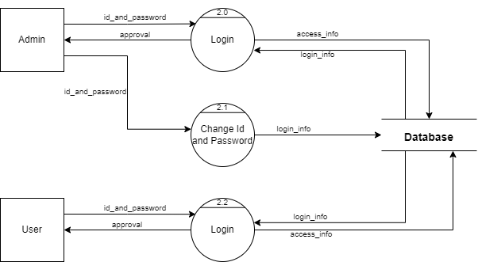

#### Fig 6.1- DFD level 2 Login

**Index (Level 2 DFD):**

2.0 - Login

2.1 - Change Id and Password

2.2 – Login

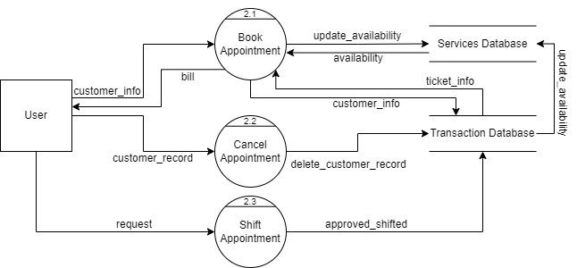

#### Fig 6.1- DFD level 2 User

**Index (Level 2 DFD):**

2.1 - Book Appointment

2.2 - Cancel Appointment

2.3 - Shift Appointment

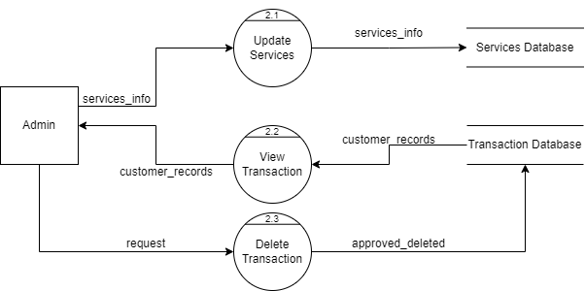

#### Fig 6.1- DFD level 2 Administrative

**Index (Level 2 DFD):**

2.1 - Update Services

2.2 - View Transaction

2.3 - Delete Transaction

## 6.2 Entity Relationship Diagram:

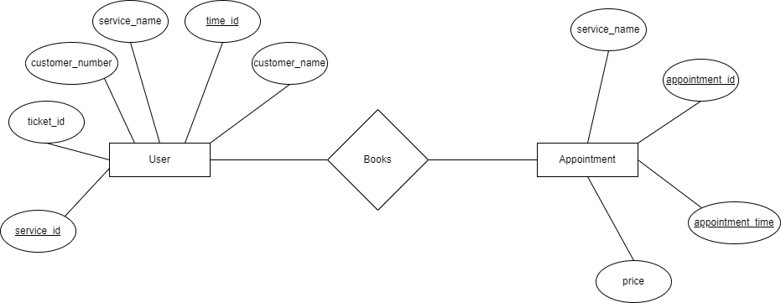

#### Fig 6.2- E-R Diagram

## 6.3 Flowchart:

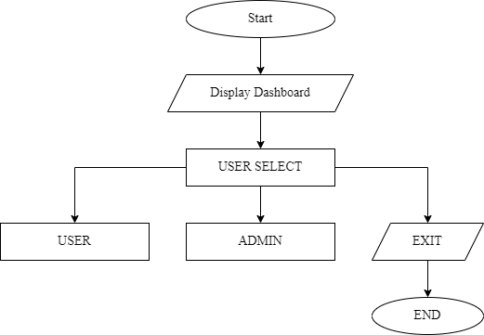

#### Fig 6.3- Select User Interface

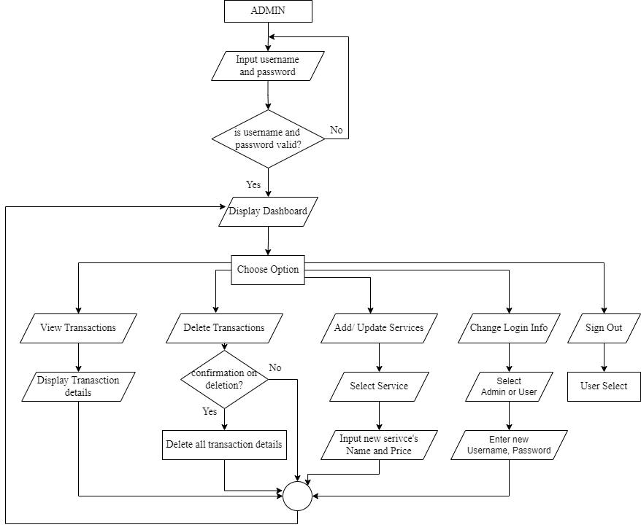

#### Fig 6.3- Administrative Flowchart

#### Fig 6.3- User Flowchart

# 7. Project Gantt Chart

#### Fig 7- Project Gantt Chart

# 8. Methodology

For the development of the “SPA appointment booking system” program, we’ll be using Incremental Model. Incremental methodology is a software development approach that involves breaking down a project into smaller, more manageable parts called increments. Each increment includes a defined set of features and functionalities that can be developed, tested, and deployed independently. It is a method of software development where the product is designed, implemented, and tested incrementally (a little more is added each time) until the product is finished. In the incremental model, instead of making one huge leap, we achieve our goals in small steps (JavaPoint, 2023).

#### Fig 8- Incremental Model

# 9. Implementation

## 9.1 Tools/ Language Used:

We chose **Visual Studio Code** (Source-Code Editor) for this project because it provides a simple and user-friendly interface. It made us easy to start writing and testing code. As Visual Studio Code does not include debugging tools, we had to install The GCC (GNU Compiler Collection) which included both complier and debugging tools.

 We have used different tools till date for different purposed. The tools we used are:

* **C Programming Language** for source code
* **Draw.io** for DFD, Flowchart and E-R Diagram
* **MS Excel** for Gantt Chart
* **MS PowerPoint** for Presentation
* **MS Word** for Documentation
* **Visual Studio Code** for Coding and Testing
* **Discord** for online meeting
* **Terminal** for application interface

## 9.2 Work Assignment

|  |  |  |
| --- | --- | --- |
| **S.N.** | **NAME** | **WORK ASSIGNED** |
| 1. | Saroj Baral | Coding, System Design, and Documentation   * Coding of major modules like book appointment, login system, schedule shiftment. * File handling * System Designs * Logic definition * Designing of Diagrams |
| 2. | R.A. Mohan Tiwari | Coding, Documentation and Testing   * Coding of modules like View transactions, delete transactions, Edit services * Testing of login systems * System Design support * Documentation * Presentation * Coding support |

#### Table 9.2- Work Division

# 10. Testing

Regardless of the development methodology, the goal of testing is to make sure that what is created does what it is supposed to do. We have included testing as a part of the development process. The test cases should be designed with maximum possibilities of finding the errors or bugs.

We have designed and executed a few test cases to check it the application meets the functional requirements.

|  |  |  |  |
| --- | --- | --- | --- |
| **TEST MODULE** | **TEST CASE** | **EXPECTED RESULT** | **TEST RESULT** |
| ADMIN | Signs up with Information for login | User successfully logged in and directed to the admin dashboard page | PASS |
| ADMIN | Enters invalid login credentials | Displays Error message | PASS |
| ADMIN | Enters View Transactions | Checks Transactions & if there is any, displays it or exits | PASS |
| ADMIN | Enters Delete Transactions | Asks for final confirmation (y/n), and format all transactions or for exit. | PASS |
| ADMIN | Enters Add/ Update Services | Asks for choice, and asks for final confirmation (y/n) & asks for service details and saves it or asks for exit | PASS |
| ADMIN | Enters Change Login Information | Asks for new Username and password and saves it | PASS |
| ADMIN | Enters Sign Out | Directs to User Selection dashboard | PASS |

## 10.1 Test Case: Admin

#### Table 10.1- Test Case of Admin

## 10.2 Test Case: User

|  |  |  |  |
| --- | --- | --- | --- |
| **TEST** **MODULE** | **TEST CASE** | **EXPECTED RESULT** | **TEST RESULT** |
| USER | Provide details for registration | User successfully registered with the application and directed to the admin page | PASS |
| USER | Enters Book appointment | Asks for choice (Services) or for exit | PASS |
| USER | Enters Cancel appointment | Asks for final confirmation (y/n) and if yes also asks for appointment info (ticket id, phone number) and directs back to User Dashboard | PASS |
| USER | Enters Shift Schedule | Asks for appointment info and also asks for final confirmation and asks for entering another available schedule | PASS |
| USER | Enters Sign out | Directs to User Selection dashboard | PASS |

#### Table 10.2- Test Case of User

# 11. Project Results

Our team successfully completed the development of our first project, which involved creating a digital platform for a spa appointment booking system. The primary goal was to modernize and streamline the business operations of spas through various innovative features.

**Key Accomplished Functions:**

In the administrator’s dashboard, we implemented features such as View transactions, delete transactions, add services, change service details, change login information and sign out. On the User side, we introduced functions for booking appointment, cancelling appointment, shifting appointment and sign out.

**Solutions to addressed problems:**

Our project effectively tackled several challenges faced by spas. We resolved issue related to appointment management, security, immediate service updates and the absence of fast booking system.

**Fulfilled Requirements:**

The project met both functional and non- functional requirements set by the spa, except for a selection of date feature as the limitation of Database Management System in C programming language. This aspect is slated for future enhancement. All business objectives, including enhanced efficiency, increased sales, improved customer experiences, security measures and a user-friendly interface, were successfully achieved.

**Benefits for Team Members:**

Our collaborative journey in developing the Spa Appointment Booking System proved to be an invaluable learning experience for all team members involved. This project fostered the growth of a wide array of skills and mindsets that will undoubtedly contribute to our future professional and personal undertakings. It notably bolstered our capabilities in teamwork, technical proficiency, time management and creative problem-solving.

# 12. Future Enhancement

The current Spa appointment booking system that we have developed provides the functionality of booking available appointments, creating account and managing the services in a Spa. The features that can be added to this system in the future are as follows:

* Use better database replacing current file-based database.
* Add the Specification and benefits of each Spa on the menu.
* Add online payment method.
* Feature for saving User’s feedback in the system.

# 13. Conclusion

The Spa Appointment Booking System (SABS) is a software solution designed to optimize the operations of a spa. Through features such as appointment booking, cancellation, rescheduling, and service management, SABS contributes to heightened efficiency and productivity. It also facilitates tasks like modifying login credentials, viewing and managing transactions. Both users and administrators benefit from its user-friendly interface and accessibility. Valuable insights for potential enhancements and identified areas for improvement are part of its outcomes. By implementing a Spa Appointment Booking System using the C programming language, the overall structure and functioning of a spa can be significantly improved. This improvement extends to better organizational practices, informed decision-making, and an elevated level of customer satisfaction. The central goal of the project was to streamline processes, reduce time consumption, and minimize errors during system administration.

# 14. Annexures

Snapshots of Project Preview:

# 15. References

*File Handling in C*. (2023, June 20). Retrieved from JavatPoint: https://www.javatpoint.com/file-handling-in-c

*JavaPoint*. (2023, 05 2). Retrieved from JavaPoint Software engineering incremental model: https://www.javatpoint.com/software-engineering-incremental-model

SPA, M. (2023, 04 29). *Malama Spa*. Retrieved from Malama Spa: https://www.malamaspa.com/